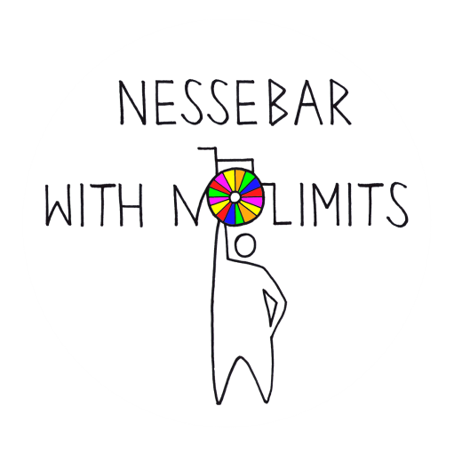
Dear Friends,
We present
The Fourth International Cultural Festival
“Nessebar With No Limits - 2018”!

We invite individual performers and collectives with disabilities that are engaged in Performing Arts in its various manifestations to take part in the Festival.
The Festival is organised by the Сouncil of Nessebar, The Bulgarian and Kazakh Association of Support and Integration for disabled people (Nessebar, Bulgaria) and The Centre of Rehabilitation for disabled people “Laykty Omir” (Karagada, Kazakhstan).
The Program is divided into categories of Performing Arts. At the present time there are 5 categories: Vocals, Choreography, Wheelchair Dance, Sign Singing and Instrumental.
To take part in the Festival applicants need to fill in the application form and send it together with videos of their performances not later than 15th of May 2018.
The Festival “Nessebar With No Limits” is held on the Black Sea coast on the stage of the ancient Amphitheatre in Nessebar, Bulgaria.
The Festival will be held from 20th to 22nd of July 2018.
Full information about the event, photos and videos of the past participants and their performances at “Nessebar With No Limits” in 2015- 2017 you can find on the official website -www.nesebarfest.com .
You can also find us on ВКонтакте and Facebook .
We are always open for a conversation!

